I-Story Brand Thought Leadership:
Tell the bigger story & find your point of view
In many ways, people hire you – for how you see the world. Most of us have a diverse background and draw upon a range of life experience to inform our point of view. It doesn’t matter whether that’s the same way your audience sees the world. What’s important is that you have something to say and share.
It’s your task to help people locate themselves in your story. You do that by revealing your perspective or vantage point. A good non-fiction writer should provide context to the reader. Subjectivity is embraced today. I just need to know where you come from. Conscious transparency leads to trust and understanding.
What’s your unique angle or orientation? Most of us sit at the intersection of converging fields and disciplines. Maybe you’re an academic with a passion for fashion? Or a venture capitalist that used to be a coder and start-up entrepreneur? It’s important to name your mashup – the places, intersections, and influences that shape how you see things.
Being a knowledge worker requires knowing a lot of different knowledge sets. It means you draw on a range of skills, domains, languages, and knowledge to do your work. It also forces you to ultimately find and define a core talent specialty. Understanding where you go broad (fluency) and where you go deep (talent) are leverage points for a powerful story.

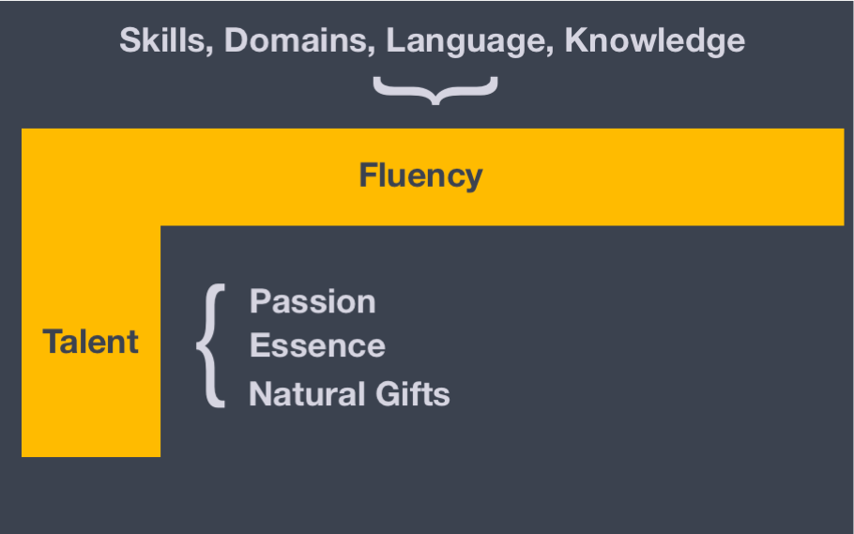

Questions to Answer: PART ONE

- What are your core areas of fluency? Think different skills, domains, languages, and knowledge sets that are critical to your profession or area of expertise. Brainstorm a big long list.

Personal Skills
Professional Skills:

- What is your talent or core genius? This should be more laser focused. We all draw on the various fluencies for doing something very specific. How would you describe it in the following terms:
Passion (your sense of purpose)
Essence (just part of how you are)
Natural Gifts (what comes easiest to share)

Natural Gifts (what comes easiest to share)

Essence (just part of how you are)

Passion (your sense of purpose)

Questions to Answer: PART TWO:

- Now its time to name the intersection. Pick three points on the map of your world that reflect your unique crossroads or vantage point. Consider the implications of this unique location. What does it allow you know, share, and reveal to others?

