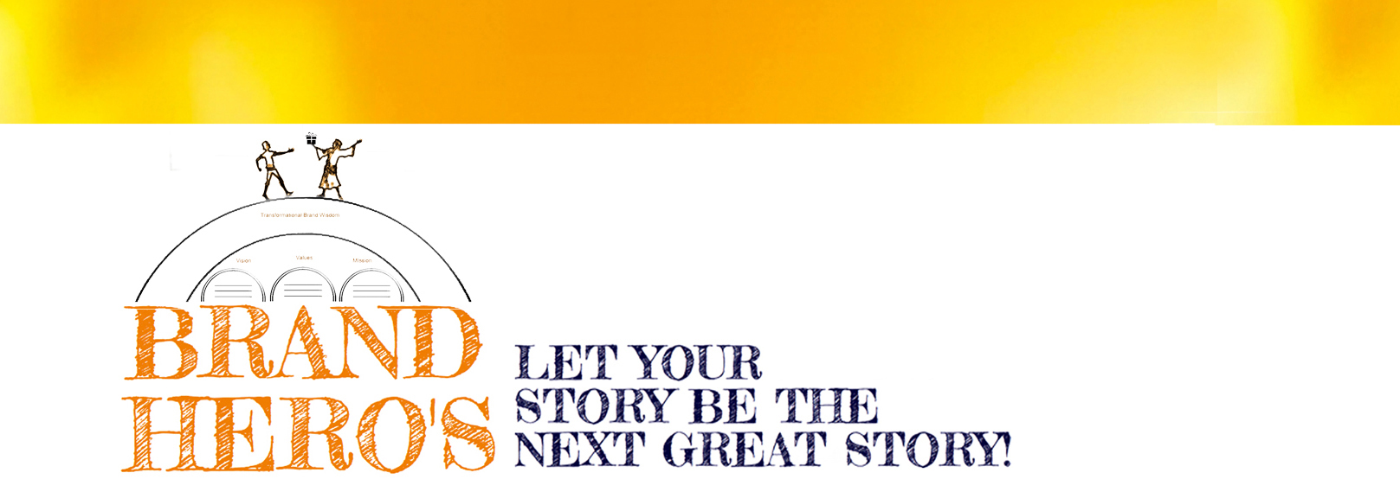

Your Super Hero Origins

OK, it’s time to think in epic terms. We each have a heroic quest or duty: a larger mission we’re here to accomplish. It’s part of the riddle you are here to solve. I know, I know – you might not feel like a hero. That’s understandable. The journey usually begins as a reluctant or accidental hero. You’re just minding your own business and being your humble self, when destiny comes rudely knocking on the door. Remember you’re not born a Superhero. Superheroes are created based on circumstances and choices. What’s yours to do?
It’s your job to connect the dots. The clues are written on the wall, and even hiding in plain sight. Remember, storytelling is the process of identifying the relationship between things. Cause and effect. Choice and consequence. How one thing is connected to the next; is connected to another thing. It’s a self-replicating pattern. Solve the Rubic’s Cube. Life is your experiment.
You have a bigger story to tell. And the world is waiting to hear it. You wouldn’t be in this program if you were looking to play small. Start thinking about what really motivates you? Life pressures and demands aside, what do you really care about? That’s the inner force guiding you forward. Few of us consciously think we volunteered for the shit we go through, yet it’s your job to look back and figure out how it all makes sense.
There’s no greater thrill or gratitude when you realize that bigger story. You discover your life holds more meaning and potential than you ever envisioned possible. That reason for being translates into a sense of confidence and natural authority. You become aligned with a deeper purpose. In contrast, consider the many well intentioned yet lost souls desperately trying to “sell themselves.” Flip the equation around. Embrace leadership as a gift-giving exercise. Genuinely take care of those around you, and you automatically become a leader.
Questions to Answer:

- What is the set-up to your heroic origins? What humble beginnings or difficult circumstances have you had to overcome? What is the origin to your powers? (Hint: usually a response to something you found missing).

- What are you willing to fight for? What REALLY motivates you and gets you up in the morning? Where do you put a stake in the ground?

- When have you felt like a misfit or outsider? What have you had to reject or give-up in order to follow your path?

- Are you in service to something larger than yourself? How would you describe this calling? Who are you here to serve? Get specific.

5. What is the larger mystery or mystery you are trying to solve? The bigger ultimate question you want to answer? What is about the world you want to put back into order?

6. Trace back your timeline and pick out 3 most defining moments that deeply shaped your identity and determined your path personally and professionally.

